Lab 9
Implementing a Remote Access VPN
Objective:
The purpose of this lab is for the student to understand configuration and implement remote access VPN using Cisco ASA and AnyConnect Secure Mobility Client
Diagram:
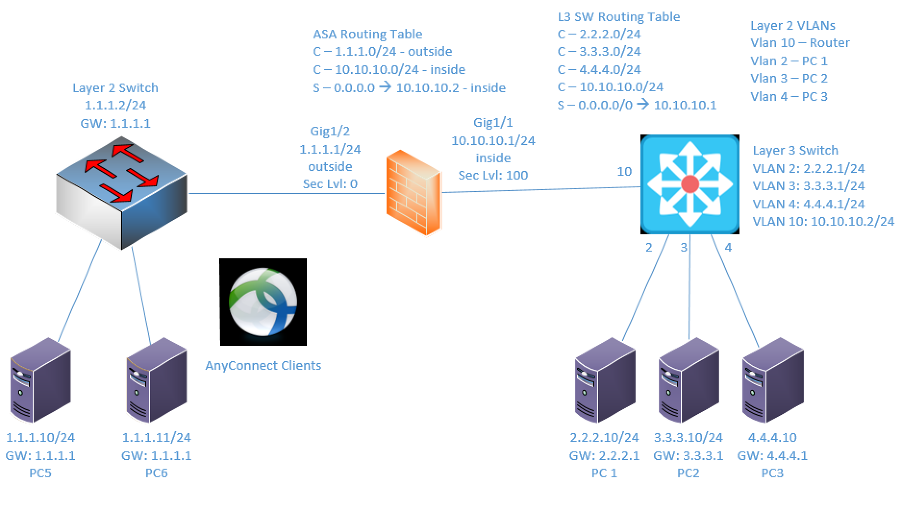
Components:
5 – PCs
1 – Cisco 3650 Layer 2 Switches
1 – Cisco 3650 Layer 3 Switches
1 – Cisco 5516-X ASA Firewall

Useful commands for this lab

show vpn-sessiondb anyconnect ! To display established AnyConnect sessions
show webvpn anyconnnect ! Show information about an AnyConnect Client image

The majority of the configuration and statistic information for this lab will be gathered from the ASDM

Procedure:
- Connect all PCs, switches and ASA as shown in the diagram above.
- Configure the IP addresses on the L3 switch interfaces and ASA firewall interfaces as shown above. The interface names, security levels and IP address info, including routing tables, are shown above.
- Make sure “ip routing” is enabled on the L3 switch as well as any routing shown in the diagram. Note: You’ll notice fewer and fewer instructions moving forward for basic networking tasks.
- Configure the ASA so that you can reach the ASDM on the inside interface from one of your internal networks. The internal networks are connected to the L3 Switch.
- Connect to the ASDM using an IP address you allowed in the previous step.
- Launch the AnyConnect SSL VPN Wizard by clicking the Wizards drop down, click VPN Wizards and finally AnyConnect SSL VPN Wizard.
  - 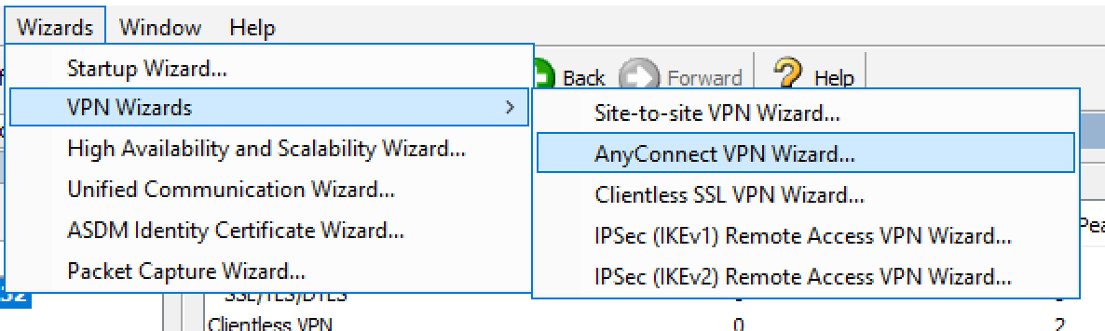
- Follow the steps in the wizard using the following information:
  - Just Click Next on the Intro step
  - Connection Profile Name: NETC230-AC-Lab
  - Outside interface
  - Protocol(s): SSL Only. No IPSec
  - Certificate: None
  - Client image: anyconnect-win-4.7.04056-webdeploy-k9.pkg (provided in Blackboard)
  - AAA Server Group: LOCAL
  - Users to be Added:
    - UN: user1 PW: password1
    - UN: user2 PW: password2
  - VPN Pool – add new
    - Starting IP: 10.50.50.10
    - Ending IP: 10.50.50.20
    - Subnet Mask: 255.255.255.0
  - DNS Servers: 8.8.8.8, 4.2.2.2
  - domain name: netc230.local
  - NAT Exempt:
    - Enabled
    - Interface: inside
    - Address Group – Include 2.X, 3.X and 4.X networks called Internal networks
  - Click Next on Client Deployment. this is an informational step.
  - Review the Configuration summary, confirm all is well and click Finish.
- As long as your configuration was accepted by the ASA without errors, you’re ready to test with one of your “outside” workstations.
- Open a browser on one of the 1.1.1.0/24 workstations and browse to https://1.1.1.1 The https portion is important. The ASA will NOT redirect you to the secure page.
- You’ll see a link to download the client. click this link. Once the client is finished downloading, launch the .exe file.
- You can accept all the defaults during the install.
- After the install is complete, open the client, enter 1.1.1.1 into the address field and click Connect.
  - Did you get an error? Yes
  - What was the information about the error? “Untrusted Server Blocked! AnyConnect cannot verify server: 1.1.1.1”
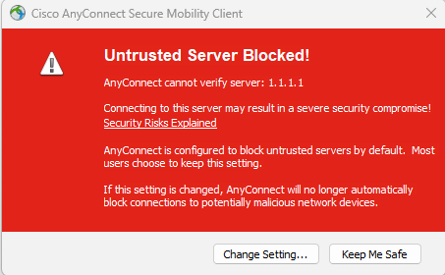
- Close the errors. Open the client a gain, but this time click the sprocket instead of adding the IP address. From the Preferences tab, Uncheck the last box that blocks connections to untrusted servers.
  - 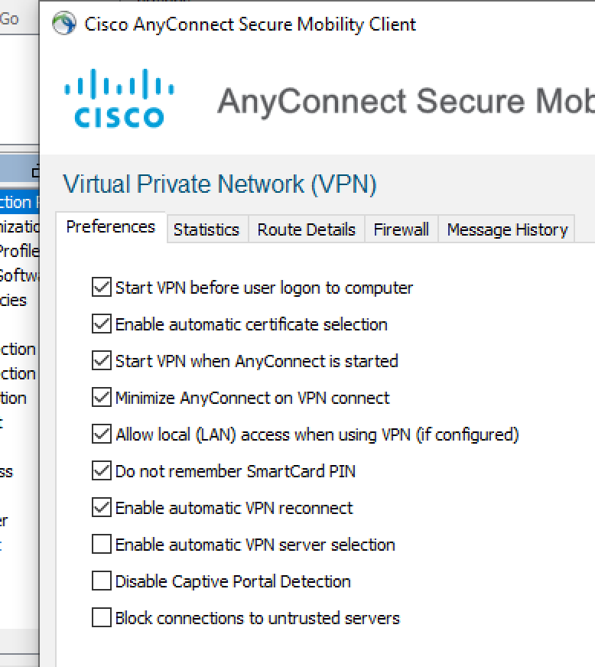
  - Close the preferences window, enter 1.1.1.1 into the address field and click connect.
- Do you still get an error? Yes
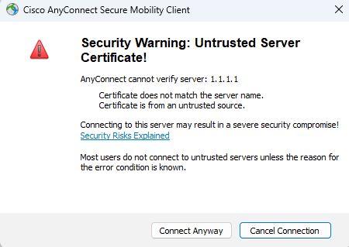
  - why? We unchecked the box that clocked connections to untrusted servers
- Click through the error by clicking Connect Anyway.
- You should be prompted for credentials. Enter the creds for user1.
- If successful, you should be able to ping the 2.x, 3.x and 4.x networks from the connected client. After successfully pinging, open the client again, click the sprocket and click the statistics tab. Paste a screen shot of the stats tab below:
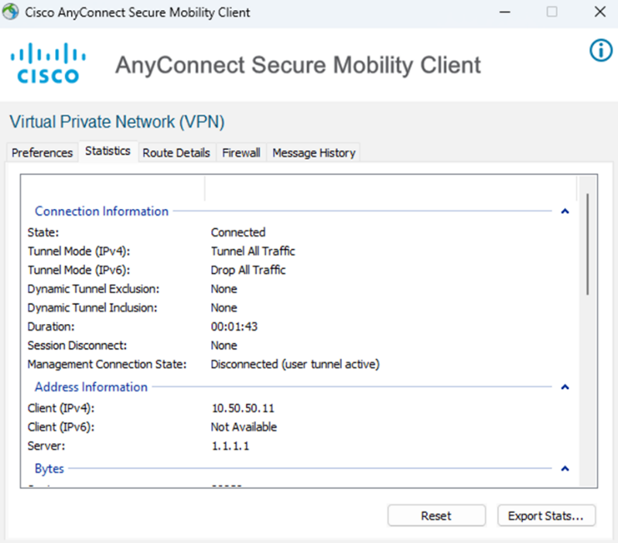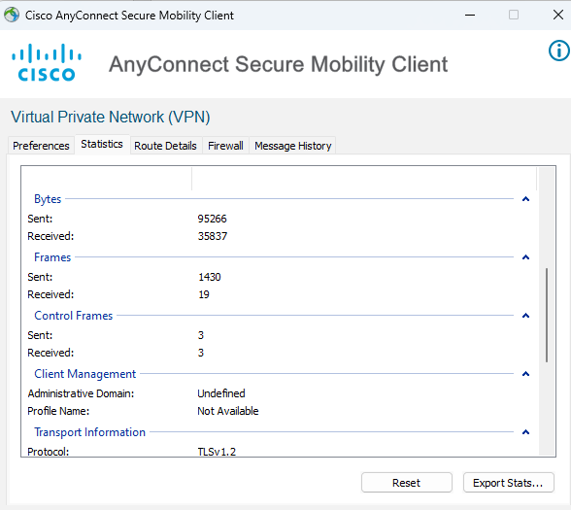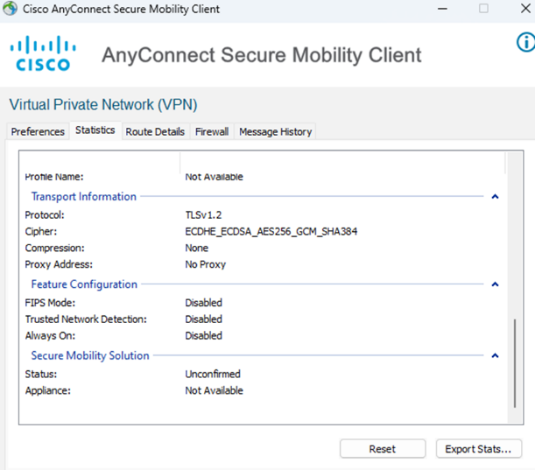

- Follow the same steps for the second workstation on the 1.1.1.0/24 network. Use user2 to connect this time. Confirm the second workstation can ping all 3 “internal” networks. Screen shot the statistics and paste them below:

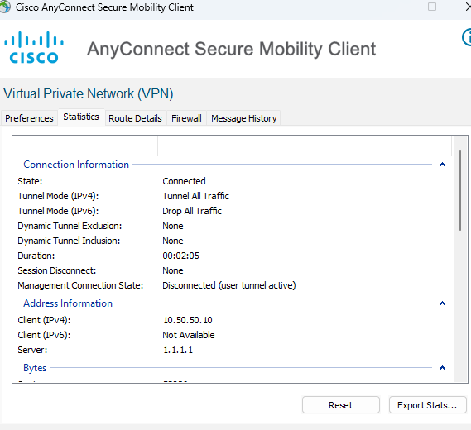
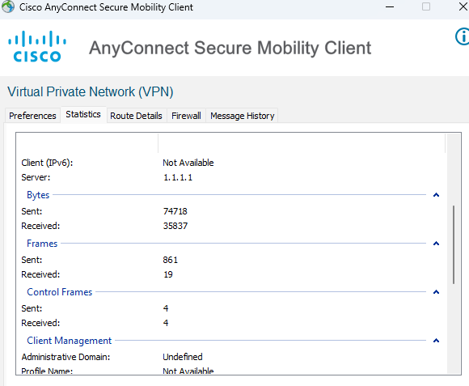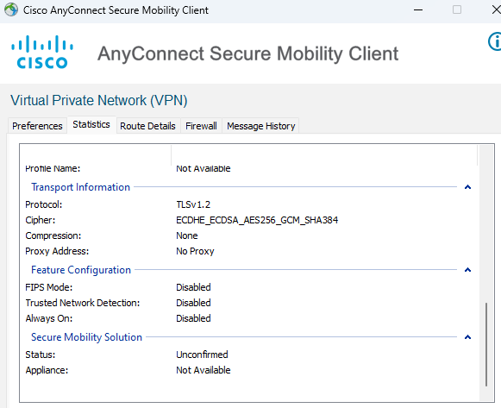

- While both “remote workstations” are connected, go back to the ASDM and browse to Monitor, VPN, VPN Statistics, Sessions.
- Click the Filter By drop down and choose AnyConnect Client.
- Do you see both clients connected with Bytes Tx and Rx populated with numbers? Yes, both clients are connected and have numbers
- Send some additional ping traffic. Click the refresh button at the bottom of the ASDM. Do the bytes seem to be increasing? I know this is a trivial question, but humor me and tell me why?
Yes, they are increasing because more traffic is going across the VPN Tunnel when we send the ping requests. The ICMP packets are traveling through the tunnel and so the bytes going across the tunnel increase.

- Screen shot your VPN statics, including the Bytes Tx/Rx and paste below.
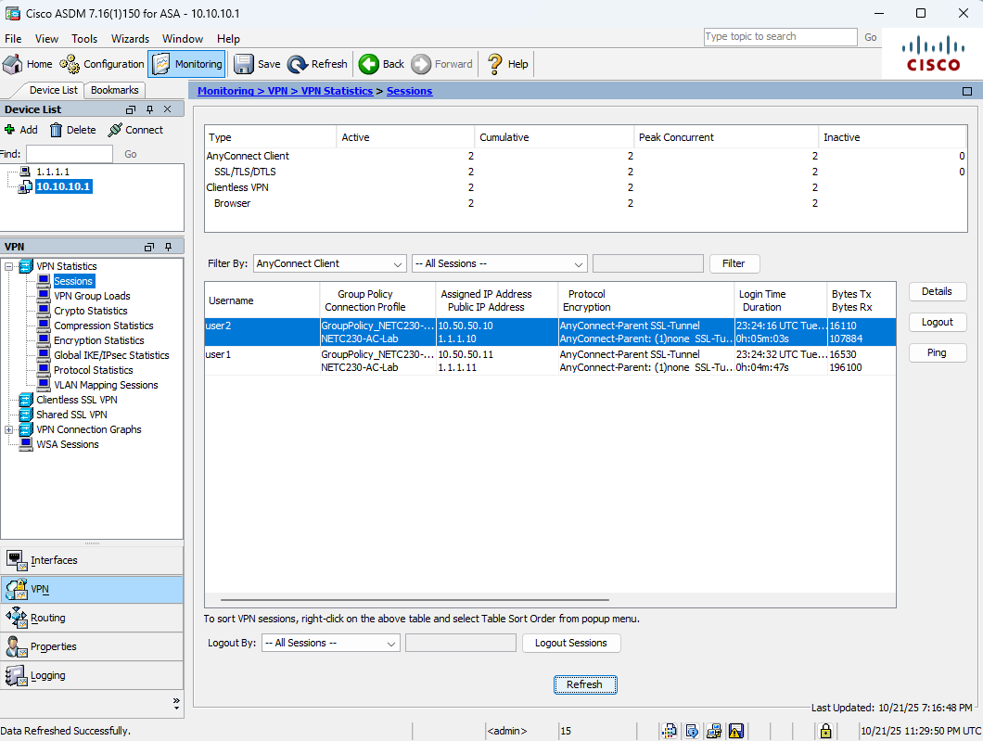
- Draw the lab diagram below (PCs, firewall and switch connections) Label the IP addresses, subnet masks, and gateways used by each device. Label the routing tables next to the routers. Label your AnyConnect VPN endpoints. Label your AnyConnect Gateway (The outside of the ASA).
